**Chapter 3**

**TECHNICAL BACKGROUND**

System design is the process of defining the architecture, components, modules, interfaces, and data for a system to satisfy specified requirements. It aims to produce a software that is efficient, flexible, secure at lowest possible cost without sacrificing the quality of the product itself.

This chapter details the research approach, software development methodology, different requirement analysis tools, and systems requirements that was used for the development of the software product.

**Research Approach**

Data gathering is needed to get the valuable data that is vital for the development of the proposed system.

The proponents decided to use a descriptive research method to gather information for the system. Descriptive Research Method has three main types which are indeed needed in accomplishing the system. First method is the Observational Method or the Field Observation, second method is Case Study that allows the proponents to study and make a testable hypothesis, and lastly the Survey Method that gathers through conducting an interview, questionnaire and survey sheet to the students and committee in-charge for the voting process.

Descriptive Research is a research used to “describe” a situation, subject, behavior, or phenomenon. It is used to answer questions of who, what, when, where, and how associated with a particular research question or problem.

The proponent’s goal is to collect data and information by conducting interviews, questionnaires and surveys to the committee-in-charge and the students of the beneficiary. This method helped the proponents in identifying specific problems encountered using the existing system. By the use of this method the proponents gathered more accurate and detailed information for the accomplishment of the system.

**Methodology**

In addition to the research approach, a methodology in building the software was also followed. The proponents decided to use RAD (Rapid Application Development) model. It is a type of incremental model. In this model the components or functions are developed in parallel as if they were mini projects. The developments are time boxed, delivered and then assembled into a working prototype.  This can quickly give the customer something to see and use and to provide feedback regarding the delivery and their requirements.

These are the phases in the rapid application development (RAD) model that the proponents decided to use:

**Business modeling**: The information flow is identified between various business functions.

**Data modeling**: Information gathered from business modeling is used to define data objects that are needed for the business.

**Process modeling**: Data objects defined in data modeling are converted to achieve the business information flow to achieve some specific business objective. Description are identified and created for CRUD of data objects.  
**Application generation**: Automated tools are used to convert process models into code and the actual system.

**Testing and turnover**: Test new components and all the interfaces.

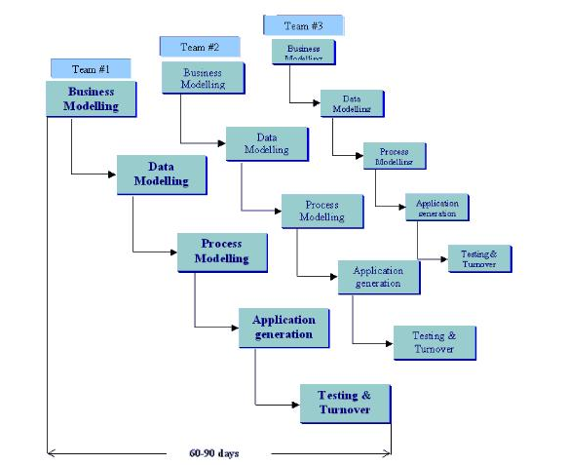 The Proponents decide to use RAD Model because of the advantages it has. First advantage of using RAD model is to reduced development time. The proponent have to develop a system in a given time interval. They must complete the system before the due date that is why the proponents decided to use the RAD model for the systems methodology. Second is it increases reusability of components. Third it makes quick initial reviews and fourth it encourages customer feedback. Lastly is the integration from very beginning solves a lot of integration issues. This methodology is the best way to view the task processed by the proponents.

**Figure 1. RAD Model**

**Requirements Analysis**

Data gathering aims to obtain the valuable data that is vital for the development of the proposed system. Here, the proponents utilized different techniques in data gathering to ensure that the system built was in accordance with what the beneficiary requires.

**Observation.** The beneficiary allowed the proponents to conduct an actual observation in their current system they are using. On July 13, 2018 the proponents went to the beneficiary for the actual observation of the school’s manual voting process. The activity begins with the students falling in line in the front of each room, where only 5 students can vote at a time. Then they give one ballot in each student. The direction of the ballots is instructed by a committee assigned in the room. The student must shade the circle at the left side of the name of the candidate they are voting. Students will put a thumb mark at the lowest part of the ballot to prove that they have already voted. The committee will count the ballots manually at the same room they conducted the voting process. The proponents observed that they are having conflict in counting the ballots. The number of total voters and the number of the total vote is not accurate. The proponents help them to correct the output written in the white board.

**Interview.** Data gathering is the main purpose in conducting an interview to the beneficiary. The proponents conducted an interview to know the main purpose of the student government voting and to gather the data needed in making the system. The committee tells the proponents that the purpose of student government is to enhanced the student leadership not only in academic but also in handling the school policies. The beneficiary is using manual preparation and manual voting process. The problem in using manual voting is time consuming in printing, conducting votes, counting votes and high costing because they still need to print the ballots.

**Questionnaire.** In gathering data the proponents prepared questions to clarify the problem when using the existing system. The proponents observed that they are still using a manual voting system and they are having the same problem like other manual voting have, the accuracy of the total number of voters and the actual count of the ballots. In this case, the proponents decided to make a system for the beneficiary that allows them to prepare, conduct the voting process and the real time counting of the ballot once been casted.

**Survey.** Data Collection is the major method to be done in making a system. It provides data’s that are needed to improve the system flow. The proponents make an interview guide question for the head committee, questionnaire for the committee and survey for the students of the beneficiary. During the data gathering, the proponents notice the same problem other manual voting have. The total number of voters and the actual total count of the ballots are not accurate. Using the existing system is time consuming in terms of preparing the voting time and date, in printing the ballots and in counting the ballots that has been casted by the students.

**Form and Document Analysis.** According to (Bowen, 2009), document analysis is a form of qualitative research in which documents are interpreted by the researcher to give voice and meaning around an assessment topic. The proponents observed that beneficiary is having trouble in using the manual voting. Furthermore, they also observed that the school principal had to assign a committee to take in-charge for the whole voting process from screening, preparation, printing and instructing during the election, and also counting the ballots.

**Systems Requirements**

Listed below are the software requirements and the suggested environment to ensure that the software as will run smoothly in the way that was intended by the developers.

**Software.**  The recommended operating system for the application is at least Windows 7, since the support for the Windows XP has been discontinued already by the Microsoft Corporation. The developers used Google Chrome as the primary testing and development ground of the software application, while the XAMPP was used in accessing the database that is running in the localhost.

Table 1

**Software Specifications**

|  |  |  |
| --- | --- | --- |
|  | Minimum | Recommended |
| Operating System | Windows 7 32bit | Windows 8 64bit or higher |
| Browser | Internet Explorer 9 | Google Chrome |
| Database (Offline) | XAMMP v3.2.2 | XAMPP v.3.2.2 or higher |

**Hardware.** As for the hardware requirements, the software application doesn’t demand very high requirements for it to run, the specifications are listed on the table below.

Table 2

**Hardware Specifications**

|  |  |  |
| --- | --- | --- |
|  | Minimum | Recommended |
| Processor | Intel Core2duo E8400 @ 3.0Ghz | Intel Core i3 3240 @ 3.4Ghz or better |
| RAM | 1GB DDR3 @1666Mhz | 4GB DDR4 @ 2100Mhz or better |

**Peopleware.** This section discusses the people involved in the development of this project, together with their respective roles.

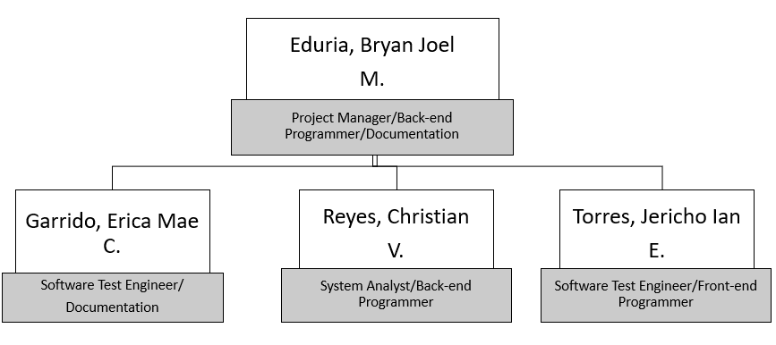

Figure 2. Organizational chart

* Project Manager – responsible for overseeing the whole project, does the decision making, ensures that the risk is under control and mitigates uncertainty in the project.
* System Analyst – determines and builds the designs for the components that are to be included in every release in a project cycle and disseminates those information with the programmers.
* Front-end Programmer – designs and builds the graphical user interface of the system.
* Back-end Programmer – the one who coverts the algorithm/business process into code. Basically, he is the one who builds the “logic” of the system itself.
* Documentation – this makes the user understand the proposed system more as it details the flow, structure and other intricacies of the system.

**Network.** The proposed project follows the Enterprise Web-based Architecture as defined by the Woodger Computing Inc., which is composed of four (4) different layers, namely: Client layer, Presentation layer, Business Logic Layer and the Data layer. Each of these layers perform different jobs in the system, and the survival of the system depends on the inter-relationships of these layers. Not all of these layers can be seen by the end-users, because some of these reside only in the server of the website.

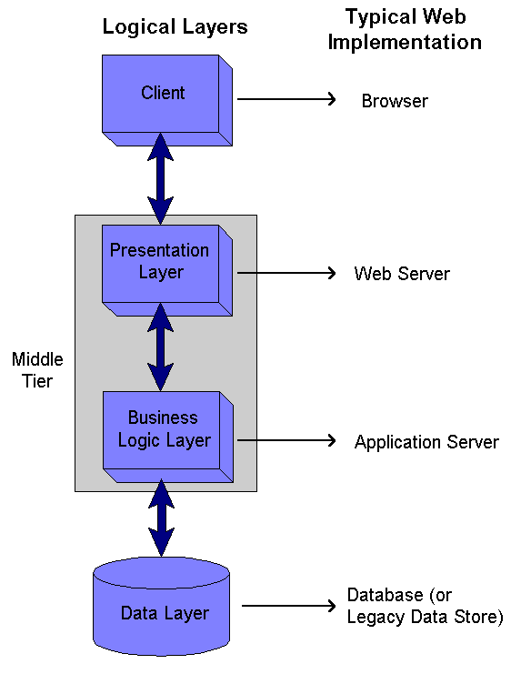

**Figure 3. Network Specifications**

* **Client Layer** – this is what the end-users will see as they visit the website. To reduce the burden on the part of the server, the semi-intelligent client approach was used. This approach includes the usage of dynamic HTML as well as jQuery, to make the application load faster, since it is using Laravel as its PHP framework, which could make an application load slower because of its numerous class mappings.
* **Presentation Layer ­**– the job of the presentation layer to generate webpages and include its dynamic content (the data, which, comes from the database). It also searches for the user-entered data in the webpage and passes it to the Business Logic Layer for validation etc.
* **Business Logic Layer** – most of the logic of the application can be found in this layer. This includes, but is not limited to, calculations, validations, and workflow management.
* **Data Layer** – simply called the database, this manages all the data that is being manipulated and processed by the application. Whenever the data is needed, its job to produce that data from its repository, as well as store data that was entered in the system.